Ecommerce web app for grocery shopping

Software Requirements Specification

Version 1.4

06/09/2020

Deepak Malempati
Omkar Abhiteja Badda
Gangadhar Yerramsetti
Sushmita Rudra
Kamal Reddy Donthireddy

Submitted in partial fulfilment
Of the requirements of
CSIS 44-691 Graduate Directed Project 1

Revision History

Date | Description | Author | Comments
06/09/2020 | 1.0 | Deepak Malempati | Added requirements R1 through R3
06/09/2020 | 1.1 | Gangadhar Yerramsetti | Added requirements R4 through R6
06/09/2020 | 1.2 | Kamal Reddy Donthireddy | Added requirements R7 through R9
06/09/2020 | 1.3 | Sushmita Rudra | Added requirements R10 through R12
06/09/2020 | 1.4 | Abhiteja Badda | Added requirements R13 through R15

Document Approval

The following Software Requirements Specification has been accepted and approved by the following:
Signature | Printed Name | Title | Date

Table of Contents

Table of Contents Page Number

- Introduction
  - Purpose
  - Scope
  - Definitions, Acronyms, and Abbreviations
  - References
  - Overview
- General Description
  - Product Perspective
  - Product Functions
  - User Characteristics
  - General Constraints
  - Assumptions and Dependencies
- Specific Requirements
  - External Interface Requirements
    - User Interfaces
    - Hardware Interfaces
    - Software Interfaces
    - Communications Interface
  - Functional Requirements
  - Use Cases
  - Class/Objects
  - Non-Functional Requirements
3.5.1. Performance
3.5.2. Reliability
    - Availability
    - Security
    - Portability
  - Inverse Requirements
  - Design Constraints
  - Logical Database Requirements
  - Other Requirements
  - Prototypes (for complete project)
  - Use Case Diagrams
- Design
4.1. ER diagram
4.2. GUI
- Analysis Models
4.1. Data Flow Diagram
4.2. Sequence Diagram

CHAPTER 1
INTRODUCTION

1.1 Purpose
The purpose of this project is to develop an e-commerce web application to users for groceries shopping. Due to global pandemic, many customers do not prefer to buy groceries by visiting the store. This web application will act as a virtual store which enables the customers to buy groceries online. The users can choose to either pick up the order from the store or get it delivered to their homes.

1.2 Scope
To develop a web application that saves a lot of time of customers that they would otherwise spend on visiting the grocery store and roam from aisle to aisle in search of the products. Users can add products listed under categories to their cart and checkout by either opting for delivery or pick up from the store. A chat box to aid the users with any required information is handled by the owner.

1.3 Definitions, Acronyms, and Abbreviations
OSS - Online Shopping System (for Grocery shopping).
SRS - Software Requirement Specification.
GUI - Graphical User Interface.
Stack-holder - The person who will participate in system or site Ex: Customer, Admin, Visitors, etc.
CSS - Cascading Style Sheet.
HTML - Hypertext Markup Language.
TCP/IP – Transmission Control Protocol/Internet Protocol.
HTTPS – Secure Hypertext Transfer Protocol.
SSL – Secure Sockets Layer.

1.4 References

1.5 Overview
The main idea of the web application is to provide customers a chance to shop groceries virtually using internet form any place and permits customers to purchase the grocery items and snacks of their own from the store. The data or information related to the products are stored on database at the server side which is at store. This server help to process the entire action performed by the customer and the selected items are shipped to the address given by customers. The web application was planned into two modules initially is for the customers who wish to purchase the grocery items and snacks, second is for the admins who keeps up and refreshes the data relating to the products, those of the customers and the admin maintains the database. Moreover the products which are selected by customer are added to the shopping cart and once the order process is done, it will be added to the list of active orders in admin portal.
Also, we provided customers with live chat system which will be part of help & assistance page and customer can track their order which will be shown in history of orders in customer account.
The rest of the SRS is organized as follows:
- Chapter2 is the General description of the project.
- Chapter3 cites the specific requirements of the project.
- Chapter4 displays the Design of the project.
- Chapter5 presents Analysis Models of the project.

CHAPTER 2

GENERAL DESCRIPTION

2.1 Product Perspective
All the stakeholders are responsible for product success. All the requirements needs to be fulfilled to achieve the product success. The requirements define the product’s functional behavior. It is important to define product requirements to reach product’s perspective. The product be available to all users and use client server model.

2.2 Product Functions
The final delivery of project should cover all the requirements and work as expected. Each functionality should be secure and all the user data should be strongly secured. The product should function in such a way that any functionality should not lead to crash of webpage.

2.3 User Characteristics
Application has users of two types, Customer and Shop owner or admin. Both of them need to have an account to access our application. Customers can only access the products which are in display and information related only to their account, whereas admin can access information related to every customer like the products which they purchased. Customers have the privilege of resetting their passwords. Admin can view the orders placed and have a track on them. In the user profile activity, customer details will be present where they can verify their orders, look for previous orders, and even edit their personal information.

2.4 General Constraints
We are a team of 5 members and have divided the work equally among ourselves to build this application. Our main agenda is to develop the application and make it ready for use in six months. To achieve that we have set up several deadlines with the latest one being on June 20th (A day before our Mid-term presentation). As our team members are located at several different places we are constantly conducting our meetings over zoom to verify that we all are going on the right path.

2.5 Assumptions and Dependencies
The progress and success of the project depends on each team member actively responding to the requirements and changes during the development stage. Tasks are divided and assigned under the assumption that assigned member is capable of delivering the task on time, else any instance requiring additional support from the team members shall be brought into discussion during team connects.

The application is available only for web. Users can check their previous orders, and can order the same items. Users can save their preferred payment methods.

CHAPTER 3

SPECIFIC REQUIREMENTS

3.1 External Interface Requirements
3.1.1 User Interfaces
- Login and signup
- Homepage
- Products page
- Checkout page
- Profile page
- Order status page
- Live chat

3.1.2 Hardware Interfaces
- Desktop or a laptop with 8GB RAM and 100GB disk space

3.1.3 Software Interfaces
- Operating System: Windows (Vista/7 or above)
- Web Browser: IE 10 or above, Mozilla FF 31 and above or Google Chrome
- Database used: Google Firebase
- Drivers: Java Runtime Environment
- Integrated Development Environment: Eclipse J2EE or Apache Tomcat, Visual Studio, HTML, CSS and JavaScript.

3.1.4 Communications interfaces
- All the pages in the application communicate with each other by passing data.
- Users can connect with system using a browser and login to buy grocery.

3.2 Functional Requirements
Requirement ID | Requirement name | Description
R1 | Login and registration for customer | Every user must able to register and login using registration details. User must be able to reset the password
R2 | Homepage with list of categories | An attractive homepage that display list of categories available in store. And display items on demand/offers
R3 | User profile management | A simple user profile with his/her account details and able to update those anytime they wish to. Functionality to logout and view the items in cart. User should be able to view the previous orders as well.
R4 | Products display | All users must be able to view all the products in chosen category. Each product should show price and quantity
R5 | Cart management | User must be able to view all the items added to the card along with the quantities and price of individual item. User can able to update cart anytime
R6 | Payment | This page should allow the user to input billing address and the means to select payment type and proceed with payment.
R7 | Checkout | This page should present information of order and the order confirmation, delivery or pick up slot details.
R8 | Help & Assistance with email and textbox | Help and assistance where user can enter information and a ticket ID will be generated and assigned to user
R9 | live chat | This chat box provides guide for site, how to order and contact details of the owner with live chat.
R10 | Order Management(track, cancel, return etc) | This page helps customer to track their order at any time to  avoid miss communication between customer and owner. User can return or cancel the orders as well.
R11 | Pickup order slot timings | During checkout, available slots for delivery are shown when delivery option is chosen and store open timings are displayed when the user chooses pickup option.
R12 | Search bar with product search feature | Every user must be able to search products available in store using a search bar.
R13 | Product filters and sort option | User must have option to filter products based on price , in stock items, quantity
R14 | Check order history | User should be able to view order history in his account.

Admin page requirements:

Requirement ID | Requirement name | Description
R15 | Login for shop owner/admin | Store owner/admin must be able to login to admin panel
R16 | Update in stock items/add new items into inventory by admin | Owner should have admin permissions and will be able to update the in stock items regularly and remove the item if it goes out of stock.
R17 | View active orders in admin account | Admin/owner should be able to view the list of new orders in his account and process them based on type of order.
R18 | Admin side customer support/chat functionality | Admin/owner will also have option to chat with customers if any complaints are raised through live chat option.
R19 | Admin dashboard | Admin will have a simple homepage to navigate through different functionalities.

CHAPTER 4

DESIGN

4.1 ER Diagram
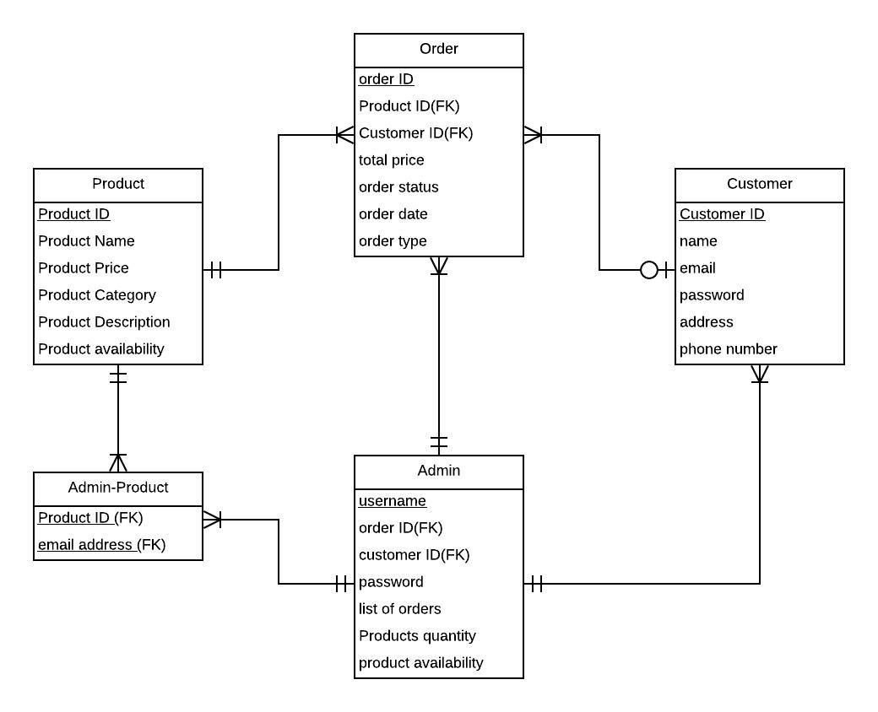

We have a total of 5 entities namely Order, Product, Customer, Admin, and an associative entity named Admin Product. Customer can be considered as a user while Admin acts as the seller. The order table has a ternary relationship with the product, customer, and admin tables.
The product table has 6 attributes of which Product ID is the primary key and there are no other foreign keys in this entity. The customer table even has 6 attributes with customer ID being the primary key without any other foreign keys.

The order table has 8 attributes with order id being the primary key while product id, customer id, and admin user name being foreign keys from a product, customer, and admin entities respectively. Admin table has 7 attributes with User name being the primary key and customer ID, product ID being the foreign keys. Admin Product is an associative entity with product ID, User names as primary keys.

Relationships:

Product: Order - 1:M
Customer: Order – 1:M
Admin: Order – 1: M
Admin: Customer – 1: M
Admin: Admin Product – 1: M
Product: Admin Product – 1: M

4.2 GUI

Home Page:

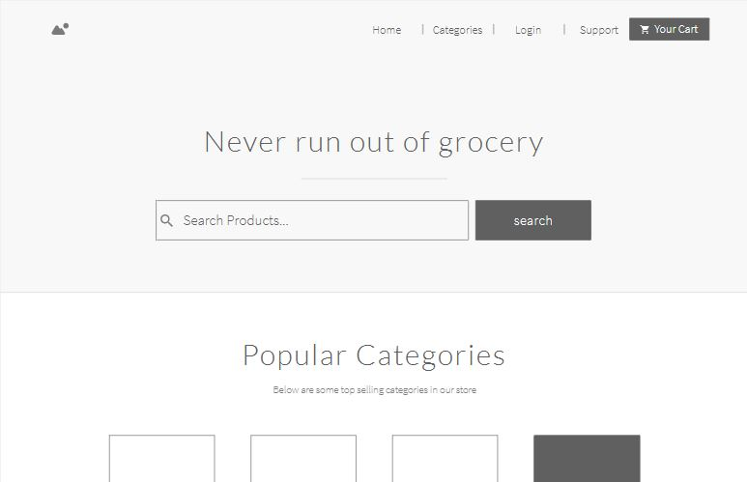

Login Page:
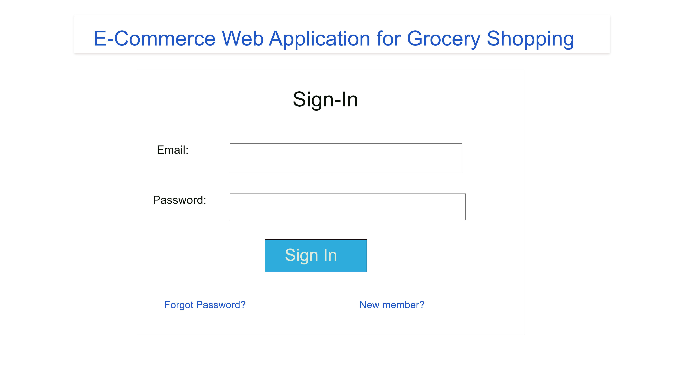

Sign Up page:

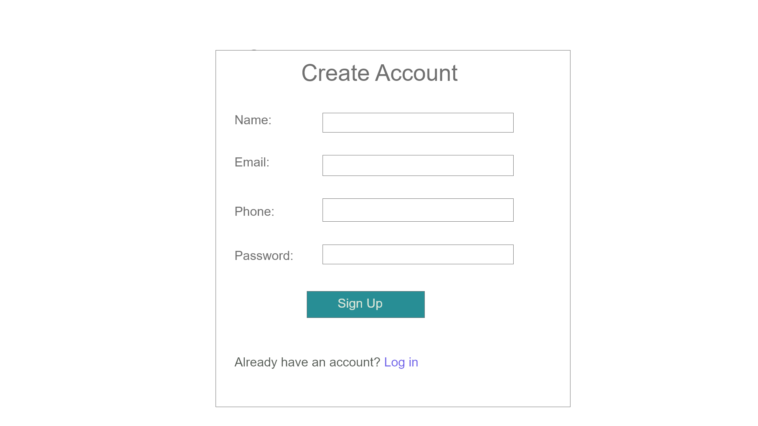

Products display page:

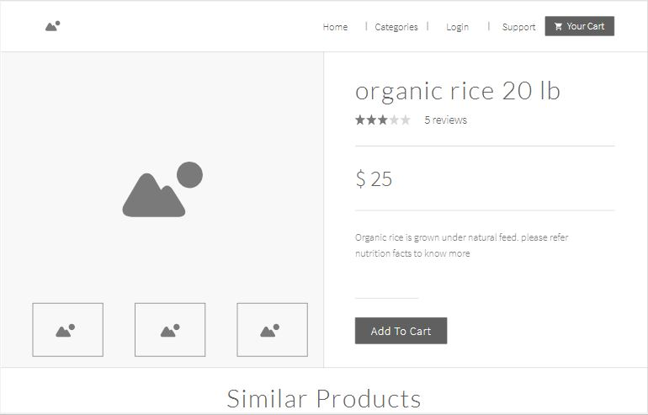

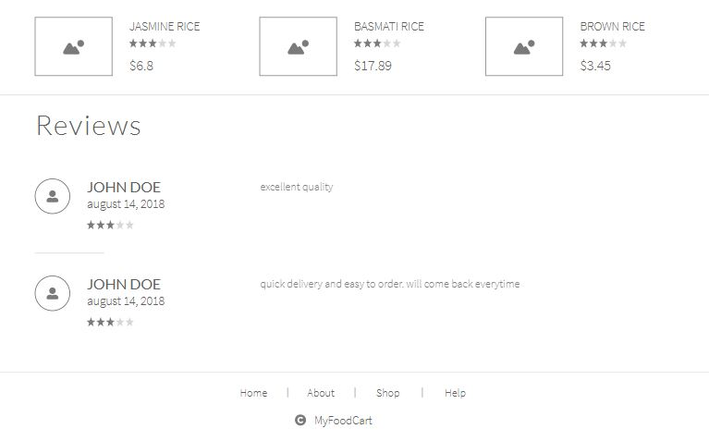

Shopping Cart:

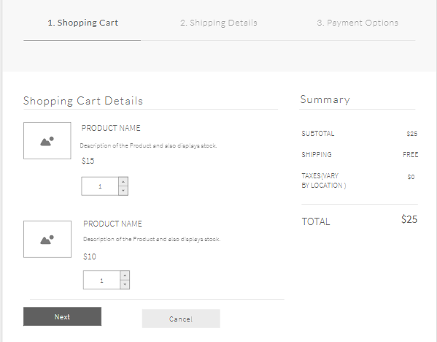

Shipping details:

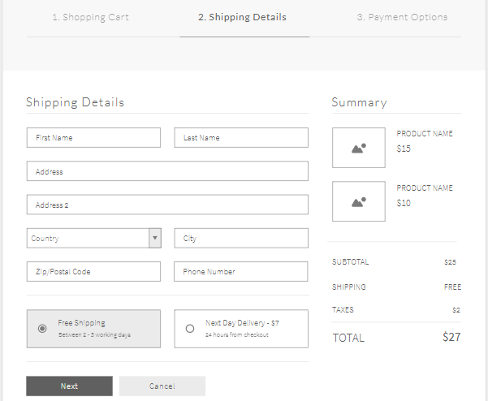

Payment:

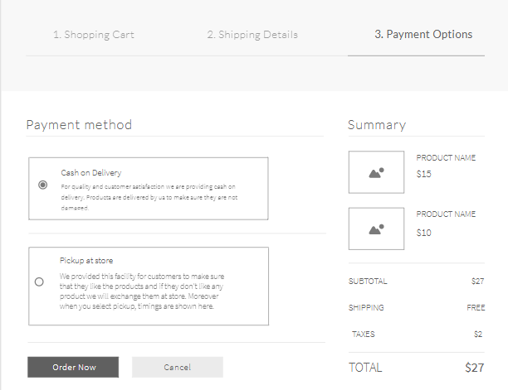

Online Chat:

